**Smart Home System For Saving Electricity**

**Project Report**

**Internet of Things**

**BTech ICT (Sem VII)**

Yug Patel (1741017)

Aditya Bajaj (1741028)

Shivansh Nautiyal (1741037)

Nisarg Gandhi (1741099)

**Under the guidance of**

**Instructor Name**

**Anurag Lakhlani**

School of Engineering and Applied Science

Ahmedabad University

Ahmedabad - 380009

**CHAPTER_1**

**INTRODUCTION**

1.1 OVERVIEW

The project deals with an interesting manner of how energy can be saved by just turning instruments of room off when not in used.

1.2 MOTIVATION

In India most of the people forgets to switch off fans and lights when they leave the room which cause a big loss of energy. Currently India Faces a huge Problem of Electricity Shortage And there are many Villages in India which still Doesn’t have electricity. So, saving Electricity is a huge task and very important for a developing Country like India.

1.3 OBJECTIVE

* Our main objective is to control lights, fans and A/C’s on the basis of human presence.
* We will be using IR sensors to count humans inside the room.
* As the person moves inside the lights will be controlled in that way.
* And as the temperature changes fans and A/C’s will be operating accordingly.
* Also, we have 4x4 Keypad for Entering the Password. And Servo Motor for Opening the Door.

**CHAPTER 2**

MARKET SURVEY

|  |  |  |  |  |  |  |
| --- | --- | --- | --- | --- | --- | --- |
| **Sr No.** | **System** | **Communication**  **Interface** | **Controller** | **User**  **Interface** | **Applications** | **Benefits** |

|  |  |  |  |  |  |  |
| --- | --- | --- | --- | --- | --- | --- |
| 1. | Philips Hue Bridge | Zig bee  wireless Network | Home  gateway and Router | Smart device | Monitoring  and Controlling Home Appliances | Effectively  Manages and Controls Home Appliances and Other devices |

|  |  |  |  |  |  |  |
| --- | --- | --- | --- | --- | --- | --- |
| 2. | LIFX Lighting Systems | Wi-Fi Module | Works on Wi-Fi System. | Led Lights | Switching  LED | Smart,  Economic and  Efficient |

|  |  |  |  |  |  |  |
| --- | --- | --- | --- | --- | --- | --- |
| 3. | Comfy Lights | Wi-Fi Network | Build in Sensors (Motion Sensor, LED, Wi-Fi, Light Sensor). | Android Phone | Comfy Light simulates Human presence at home realistically through light, so deterring intruders. | Convenience, safety, and Power-saving |

**CHAPTER 3**

BLOCK DIAGRAM

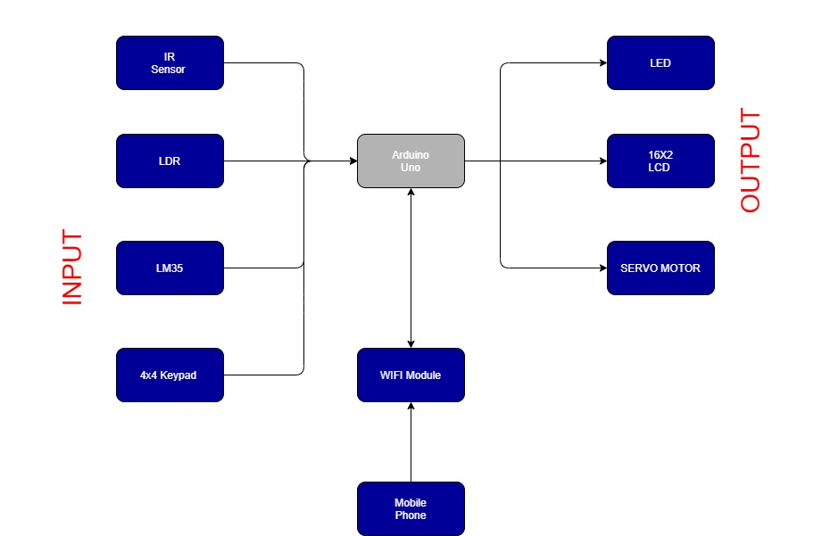

* First, Person will Enter the Password in 4X4 KeyPad. If the password is Correct the door (Servo Motor) will open (Rotate 90 Degree).
* After That when person will pass through the Door, IR Sensor will detect it and display the Count of No of Persons in the Room on 16X2 LCD.
* The Room will be divided in 2 Parts, Left & Right and there will be an IR Sensor in each part which will detect presence of person in each part.
* In Each part there will be a LM35 and a LDR to check the temperature and light intensity.
* Fan and A/c’s will be Controlled and turned ON and OFF on the bases of temperature readings provided by LM35.
* Lights will be Controlled and turned ON and OFF on the bases of Natural Light Intensity readings provided by LDR.
* All this data will be available to the user on his mobile phone. This data will be transferred using internet by ESP8266WiFi Module.
* Input for the System will be password on the 4X4 KeyPad, The Human Presence detected IR Sensors, Natural Light Intensity detected by LDR, Temperature Readings Taken by LM35.
* Output for the System will be Counts of No of Humans & Current Temperature on 16X2 LCD, Fans, AC’s and Lights as LED’s and Servo Motor as door.

**CHAPTER 4**

SYSTEM ARCHITECTURE

CIRCUIT DIAGRAM

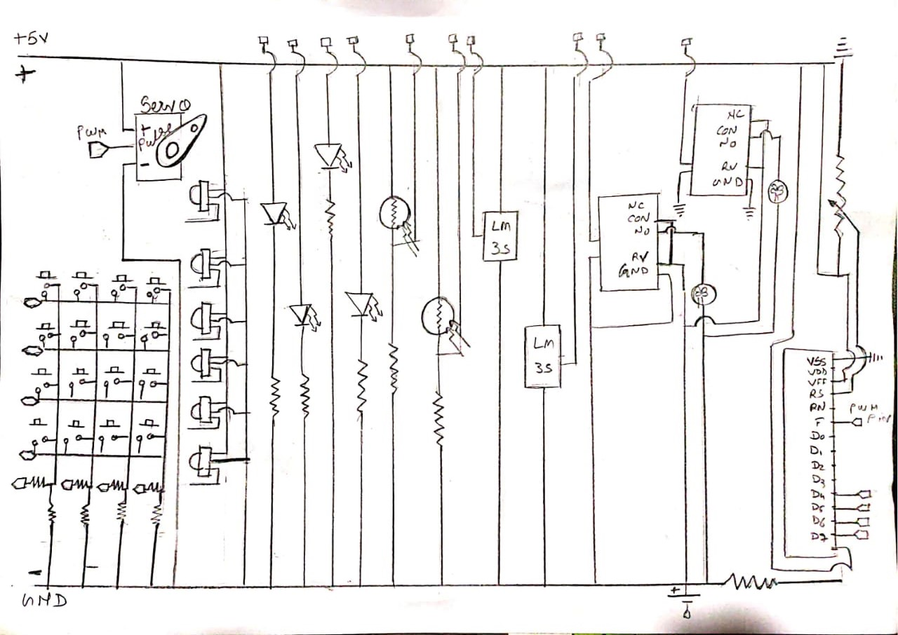

**HARDWARE AND SOFTWARE REQUIREMENTS**

* **Hardware Components**

1. ARDUINO MEGA

2. 16x2 CHARACTER LCD

3. IR SENSOR

4. LDR

5. LM35 TEMPERATURE SENSOR

6. 12V FAN

7. SERVO MOTOR

8. 4x4 KEYPAD

9. RELAY DRIVER

10. RESISTORS

11. LEDS

12. JUMPER WIRES

13. BREAD BOARD

* **Software Requirements**

1. Embedded C programming
2. ARDUINO
3. TinkerCad

* There Are Several Inputs and Several Outputs in the System
* Inputs: IR Sensors, LM35, LDR, 4X4 KeyPad.
* Outputs: 16X2 Lcd, Led, Servo Motor.
* Selection Criteria:

1. LM35: Minimum and Maximum Input Voltage is 35V and -2V respectively. Typically, 5V. Can measure temperature ranging from -55°C to 150°C. Output voltage is directly proportional (Linear) to temperature (i.e.) there will be a rise of 10mV (0.01V) for every 1°C rise in temperature. ±0.5°C Accuracy. Drain current is less than 60uA. Low cost temperature sensor. Small and hence suitable for remote application. Available in TO-92, TO-220, TO-CAN and SOIC package.
2. LDR: Can be used to sense Light. Easy to use on Breadboard or Perf Board. Easy to use with Microcontrollers or even with normal Digital/Analog IC. Small, cheap and easily available. Available in PG5, PG5-MP, PG12, PG12-MP, PG20 and PG20-MP series.
3. IR Sensor: IR sensors read moving objects. Contact-based temperature sensors do not work well on moving objects. Infrared temperature sensors are ideally suited for measuring the temperatures of tires, brakes and similar devices. IR sensors don’t wear. No contact means no friction. Infrared sensors experience no wear and tear, and consequently have longer operating lives. IR sensors can provide more detail. An IR sensor can provide greater detail during a measurement than contact devices, simply by pointing it at different spots on the object being read. IR sensors can be used to detect motion by measuring fluctuations in temperature in the field of view.
4. 4X4 KeyPad: Maximum Voltage across EACH SEGMENT or BUTTON: 24V. Maximum Current through EACH SEGMENT or BUTTON: 30mA. Maximum operating temperature: 0°C to + 50°C. Ultra-thin design. Adhesive backing. Easy interface. Long life.
5. 16X2 LCD: Operating Voltage is 4.7V to 5.3V. Current consumption is 1mA without backlight. Alphanumeric LCD display module, meaning can display alphabets and numbers. Consists of two rows and each row can print 16 characters. Each character is built by a 5×8-pixel box. Can work on both 8-bit and 4-bit mode. It can also display any custom generated characters. Available in Green and Blue Backlight
6. Servo Motor: The servo motor is specialized for high-response, high-precision positioning. As a motor capable of accurate rotation angle and speed control, it can be used for a variety of equipment.

**CHAPTER 5**

MICROCONTROLLER FEATURES

|  |  |  |  |  |  |
| --- | --- | --- | --- | --- | --- |
| **Microcontroller** | **Arduino UNO** | **Raspberry Pi** | **Beagle Bone** | **Intel’s Galileo** | **Intel’s Edison** |
| **Features** |
| **Microprocess or** | ATmega32 8 | 1.2 GHz 64-bit  quad-core ARM  Cortex-A53 | 1GHz AM335x ARM®  Cortex-A  8 | Intel Quark SoC X1000  Application Processor | Intel Atom 500MHz dual-core,  dual-threaded CPU and an Intel Quark 100MHz microcontroller |
| **Clock Speed** | 16MHz | 700  MHz to 1.4  GHz | 300 MHz  to 1 GHz | 400 MHz | 500 MHz |
| **Operating**  **Voltage** | 7 to 12 V | 5.1 V | 5 V | 3.3V or 5V | 1.8V |
| **Flash Memory** | 32 KB | 4 GB | 4 GB/256  MB | 8M |  |
| **SRAM** | 2 KB |  |  | 512 KB | 192 KB |
| **EEPROM** | 1 KB |  |  | 8 KB |  |
| **Digital I/O pins** | 14 | 26 | 92 | 14 | 20 |
| **Analog input**  **pins** | 6 | - | 8 | 6 | 6 |
| **Programing Languages** | C, C++ | Python, C, C++,  Java, Scratch, and Ruby | C, C++,  Python, Perl, Ruby, Java, or even a shell  script | C, C++, Python, Node.js/ JavaScript | Python, Node.JS, C/C++ |

**CHAPTER 6**

FLOW CHART

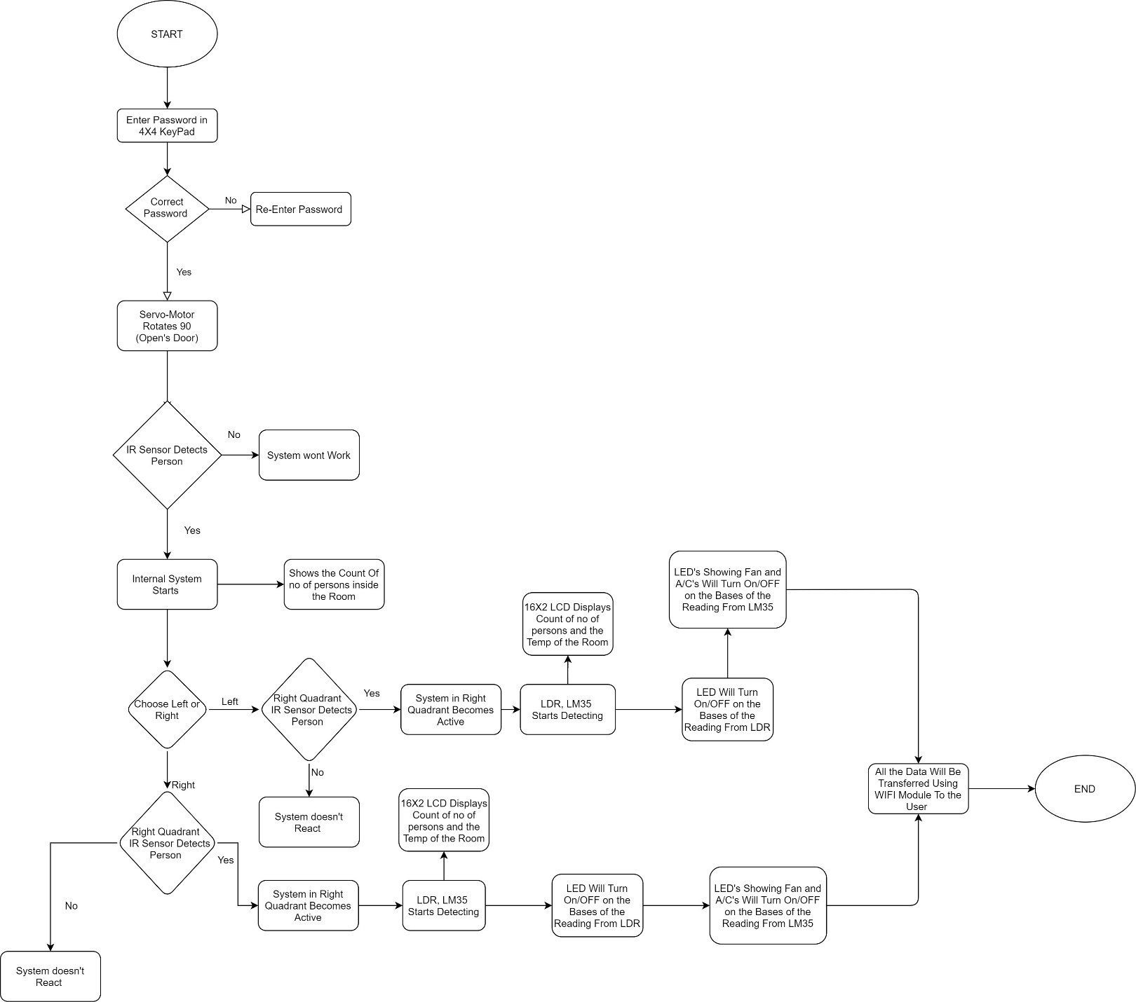

**CHAPTER 7**

SENSOR’S DETAILS

***IR Sensor***

1. **Operating Principle with Diagram**

An infrared sensor is an electronic instrument that is used to sense certain characteristics of its surroundings. It does this by either emitting or detecting infrared radiation. Infrared sensors are also capable of measuring the heat being emitted by an object and detecting motion.

Infrared technology is found not just in industry, but also in every-day life. Televisions, for example, use an infrared detector to interpret the signals sent from a remote control. Passive Infrared sensors are used for motion detection systems, and LDR sensors are used for outdoor lighting systems. The key benefits of infrared sensors include their low power requirements, their simple circuitry and their portable features.

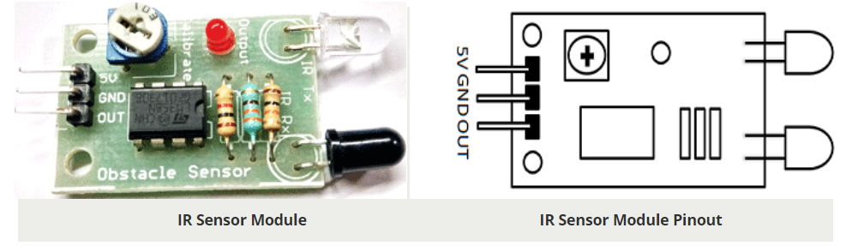

1. **Measurement Range**

The Range of IR Sensor is up to 20cm.

1. **Physical Dimension**

Size: 50 x 20 x 10 mm (L x B x H)

Hole size: φ2.5mm

1. **Power rating details**

Operating voltage 5VDC

I/O pins are 5V and 3.3V compliant

1. **Pin Diagram**

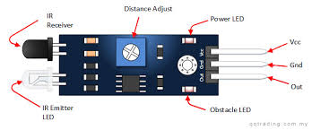

1. **Interfacing with Arduino**

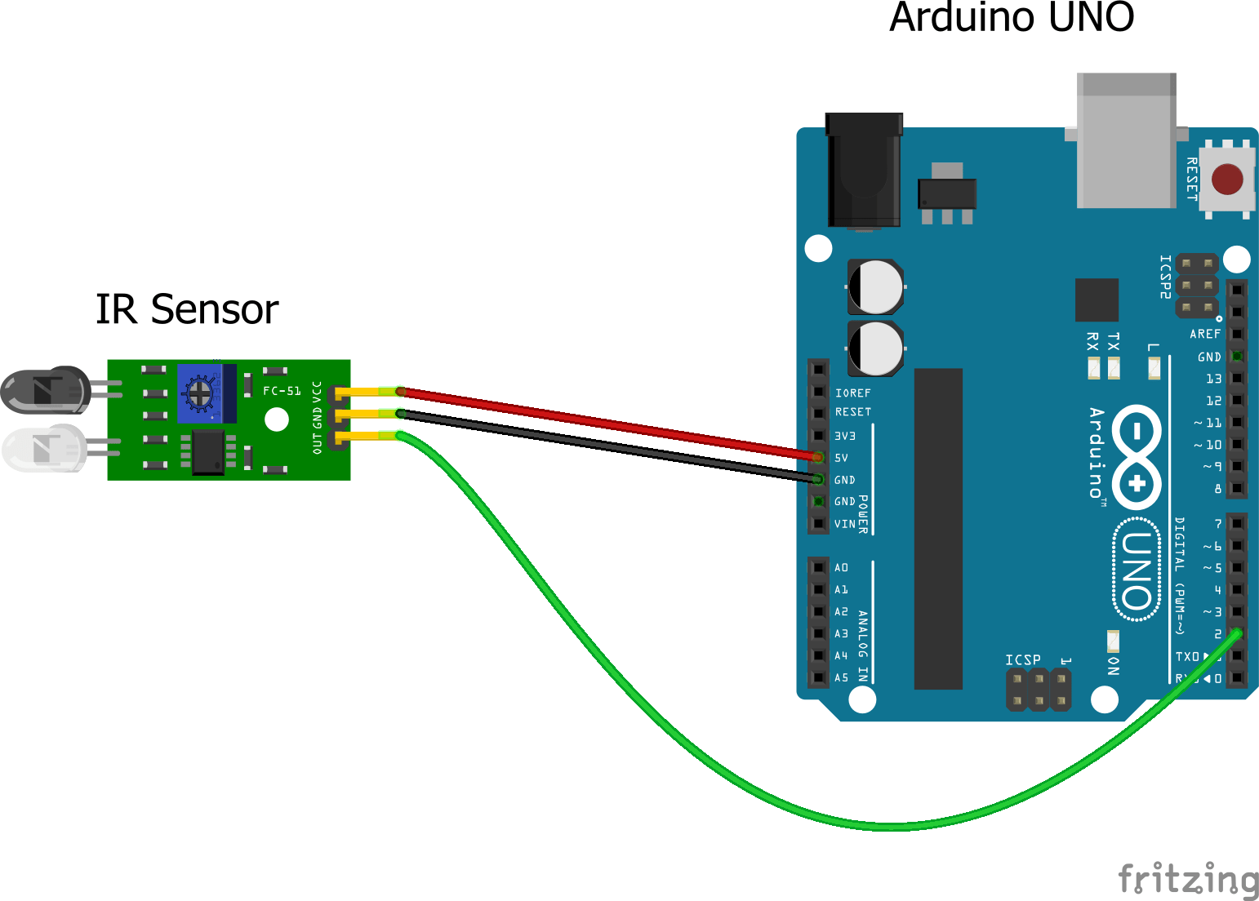

**Simulation Interface of IR And Arduino**

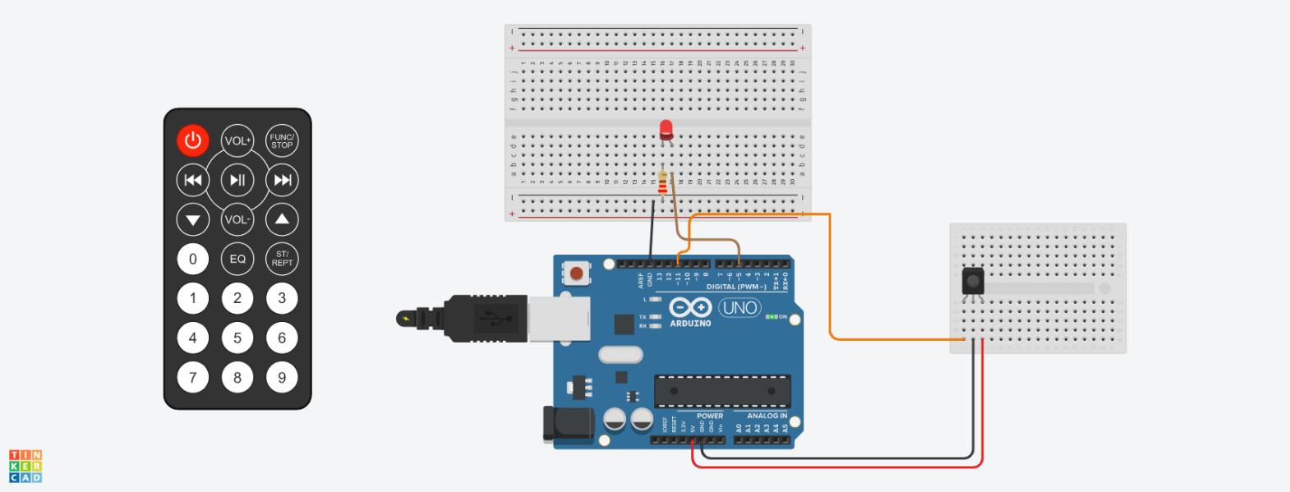

***LDR***

1. **Operating Principle with Diagram**

Photoresistor or LDR (Light Dependent Resistor), as the name suggests will change it resistance based on the light around it. That is when the resistor is placed in a dark room it will have a resistance of few Mega ohms and as we gradually impose light over the sensor its resistance will start to decrease from Mega Ohms to few Ohms. This property helps the LDR to be used as a Light Sensor. It can detect the amount of light falling on it and thus can predict days and nights or can be used for changing the intensity of lights.

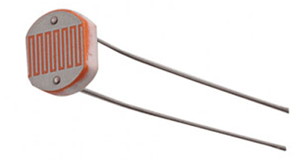

1. **Measurement Range**

Operating temperature: -25 Degree Celsius to +75 Degree Celsius

Guide to source illuminations

Light source Illumination LUX

Moonlight 0.1

60W Bulb at 1m 50

1W MES Bulb at 0.1m 100

Fluorescent Lighting 500

Bright Sunlight 30,000

1. **Physical Dimension**

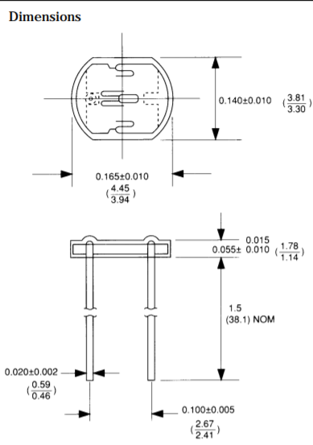

1. **Power rating details**

Peak Voltage: 100V Max

Current: 5mA

1. **Pin Diagram**

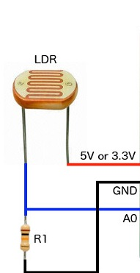

1. **Interfacing with Arduino**

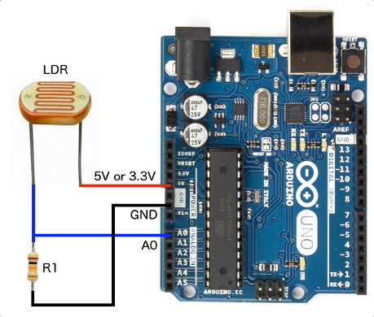

**Simulation Interface of LDR And Arduino**

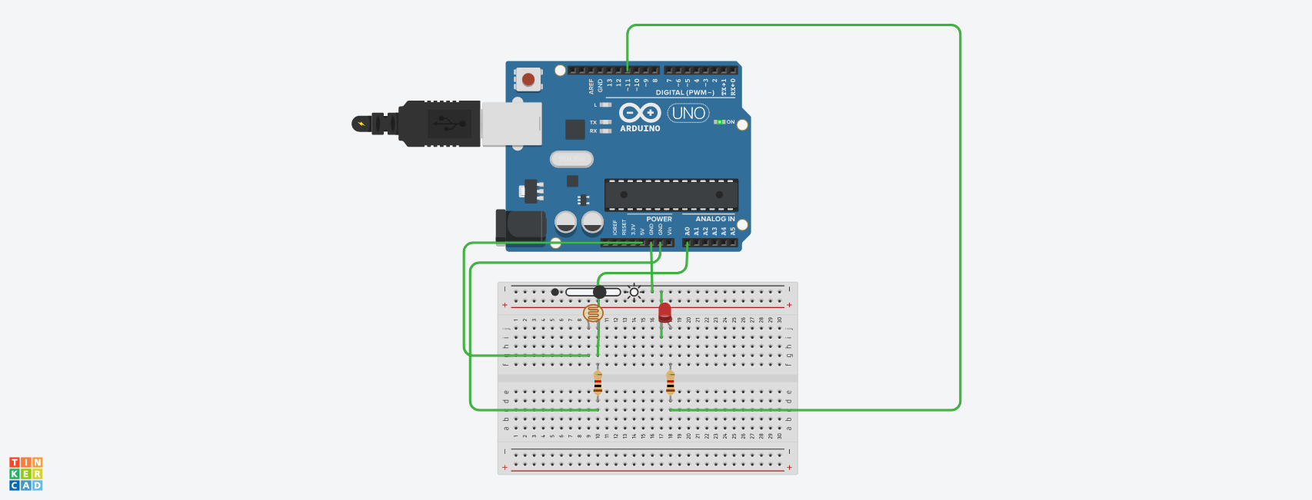

***LM35***

1. **Operating Principle with Diagram**

In principle, the sensor will perform sensing when the temperature changes every 1 ºC temperature will show a voltage of 10 mV. In placing the LM35 can be affixed with adhesive or can be cemented on the surface but the temperature will be slightly reduced by about 0.01 ºC being absorbed in the surface temperature. In this way the expected difference between the air temperature and the surface temperature can be detected by a sensor LM35 same temperature as the surrounding, if the surrounding air temperature is much higher or much lower than the surface temperature, the LM35 is the surface temperature and the temperature of the surrounding air.

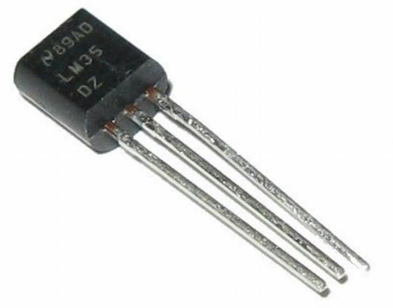

1. **Measurement Range**

LM35 Measurement Range is from -55 degree Celsius to +150 Degree Celsius

1. **Physical Dimension**

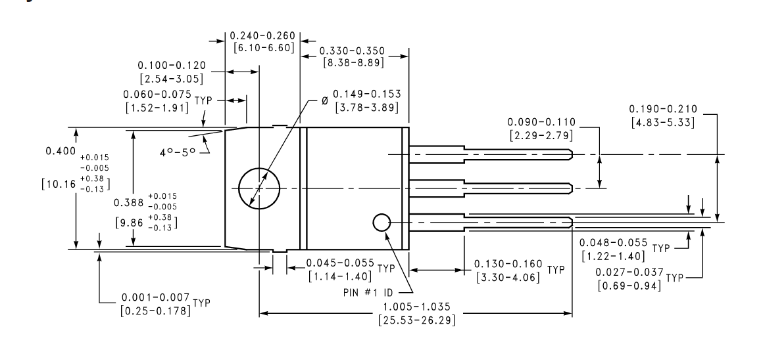

1. **Power rating details**

Operating Voltage: 4V – 30V

Supply Voltage: 5V

1. **Pin Diagram**

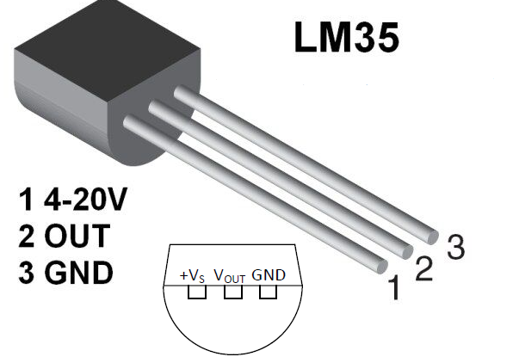

1. **Interfacing with Arduino**

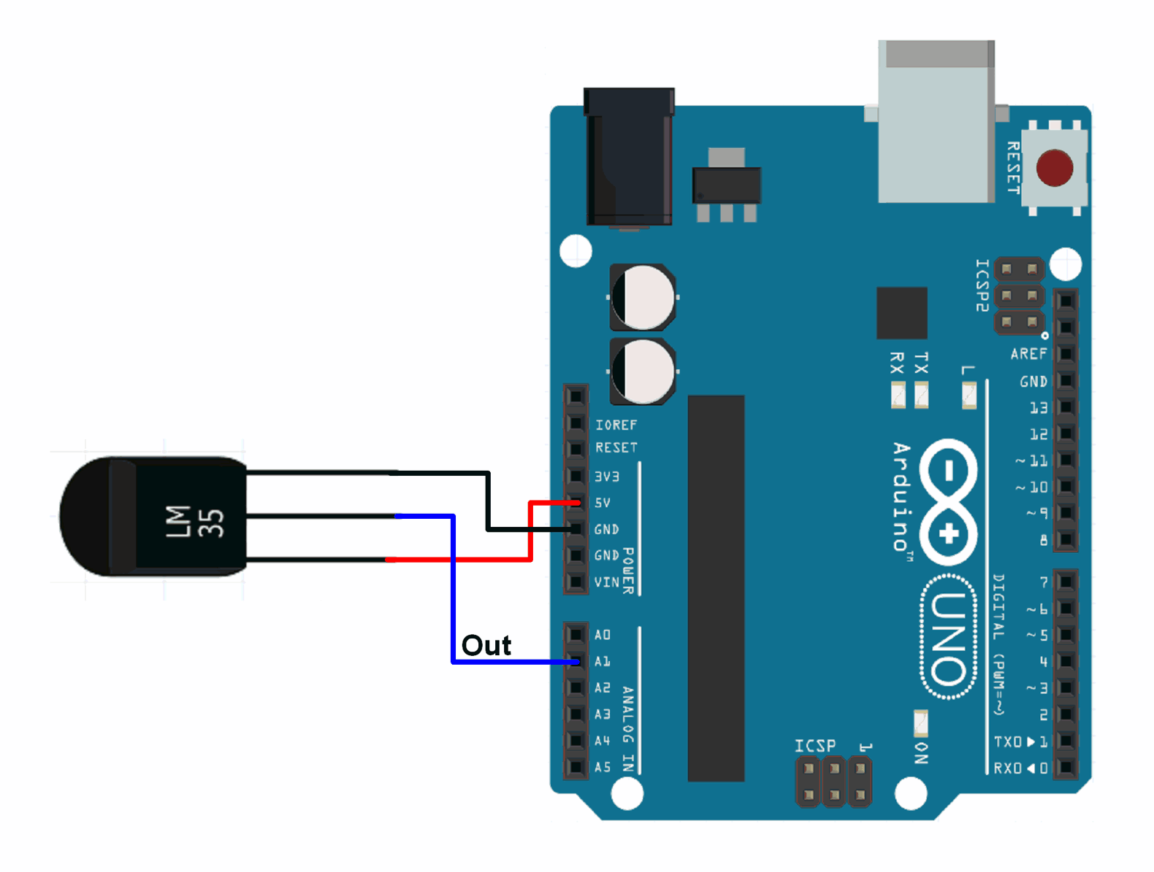

**Simulation Interface of LM35 And Arduino**

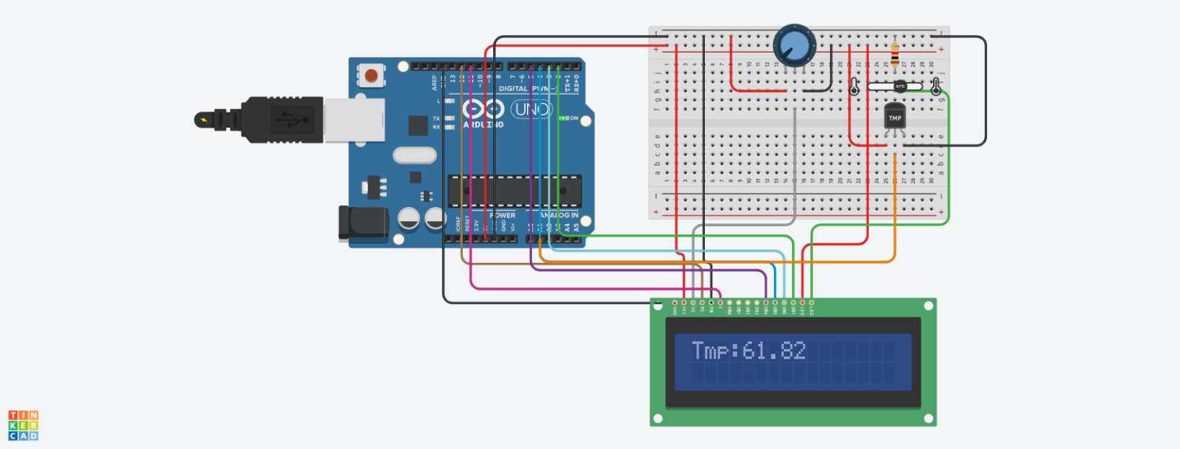

**CHAPTER 8**

ACTUATORS AND DISPLAYS

***Liquid crystal display (LCD 16x2)***

1. **Operating Principle with diagram**

LCD modules are very commonly used in most embedded projects, the reason being its cheap price, availability and programmer friendly. Most of us would have come across these displays in our day to day life, either at PCO’s or calculators. The appearance and the pinouts have already been visualized above now let us get a bit technical.

16×2 LCD is named so because; it has 16 Columns and 2 Rows. There are a lot of combinations available like, 8×1, 8×2, 10×2, 16×1, etc. but the most used one is the 16×2 LCD. So, it will have (16×2=32) 32 characters in total and each character will be made of 5×8 Pixel Dots. A Single character with all its Pixels is shown in the below picture.



Now, we know that each character has (5×8=40) 40 Pixels and for 32 Characters we will have (32×40) 1280 Pixels. Further, the LCD should also be instructed about the Position of the Pixels. Hence it will be a hectic task to handle everything with the help of MCU, hence an Interface IC like HD44780is used, which is mounted on the backside of the LCD Module itself. The function of this IC is to get the Commands and Data from the MCU and process them to display meaningful information onto our LCD Screen. You can learn how to interface an LCD using the above-mentioned links. If you are an advanced programmer and would like to create your own library for interfacing your Microcontroller with this LCD module then you have to understand the HD44780 IC is working and commands which can be found its datasheet.

1. **Measurement Range**

This Bluetooth module can cover maximum 9 meter of signal.

1. **Physical Dimension**

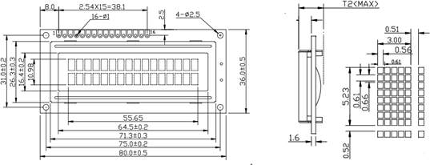

1. **Power rating details**

Operating voltage : 4.7V – 5.3V DC Supply voltage : 5V DC

1. **Pin Diagram**

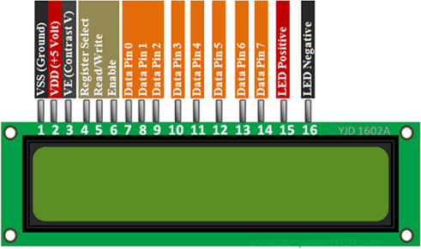

1. **Interface with Arduino**

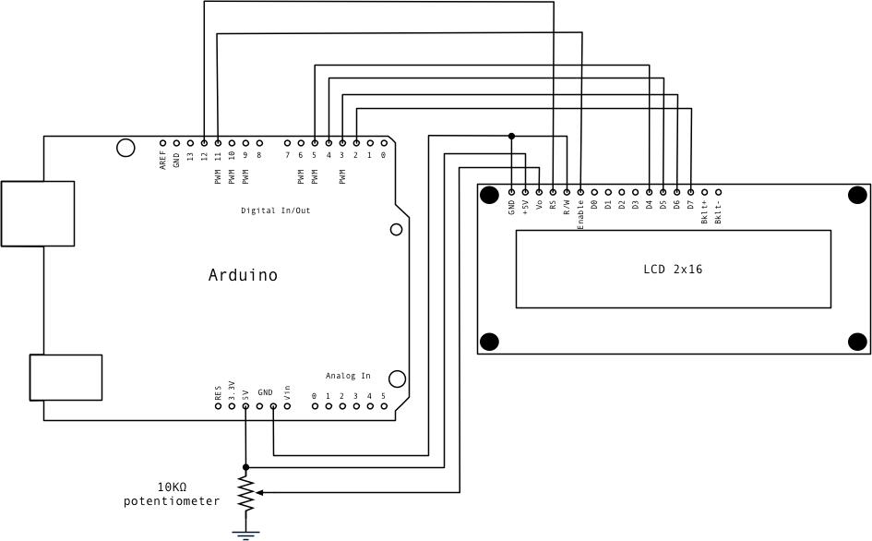

**Simulation Interface Of 16X2 LCD Display and Arduino**

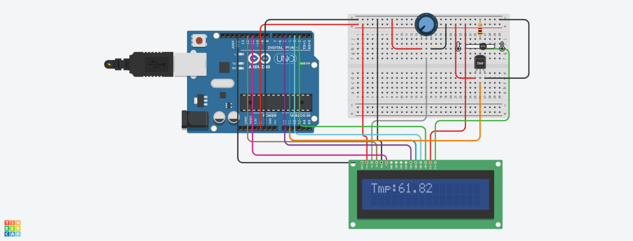

***Servo Motor (Actuator)***

1. **Operating Principle with diagram**

Servo motor works on the PWM (Pulse Width Modulation) principle, which means its angle of rotation is controlled by the duration of pulse applied to its control PIN. Basically, servo motor is made up of DC motor which is controlled by a variable resistor (potentiometer) and some gears.

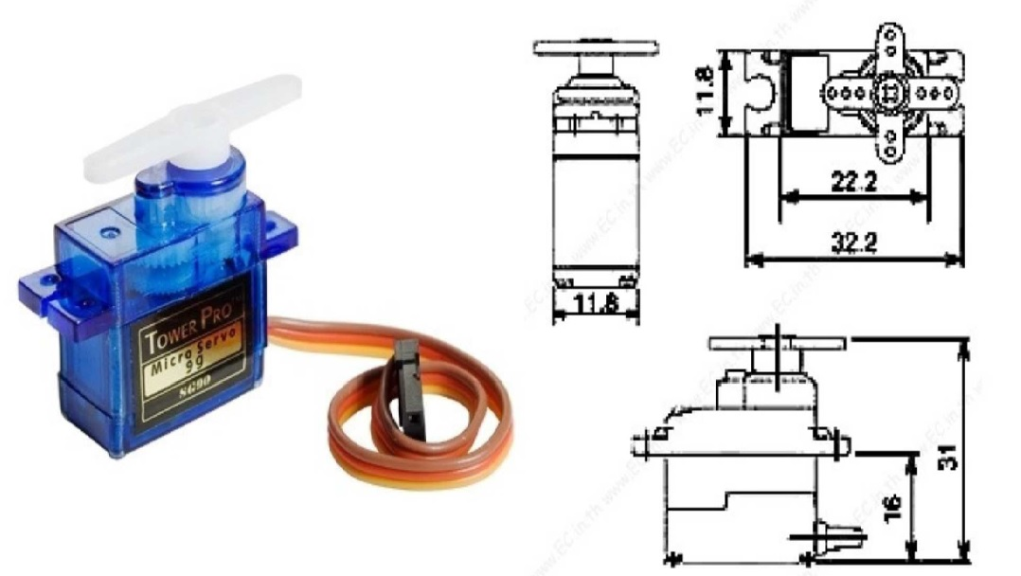

1. **Measurement Range**

Rotational Range Is 180 Degree

1. **Physical Dimension**

**Length:** 0.91 in (23.1 mm)

**Width:** 0.48 in (12.2 mm)

**Height:**1.14 in (29.0 mm)

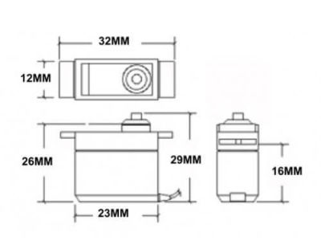

1. **Power rating details**

Operating voltage : 4.8V DC

Supply voltage : 5V DC

1. **Pin Diagram**

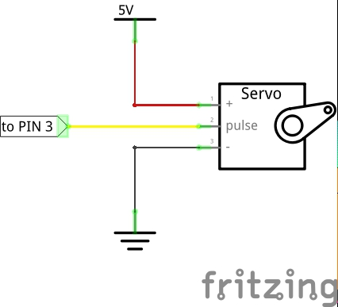

1. **Interface with Arduino**

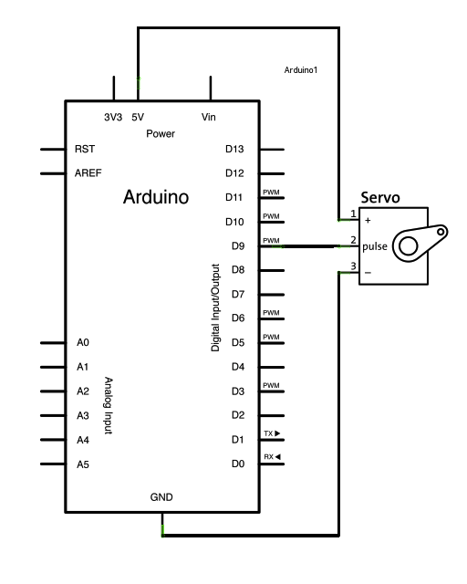

**Simulation Interface of Arduino And Servo Motor.**

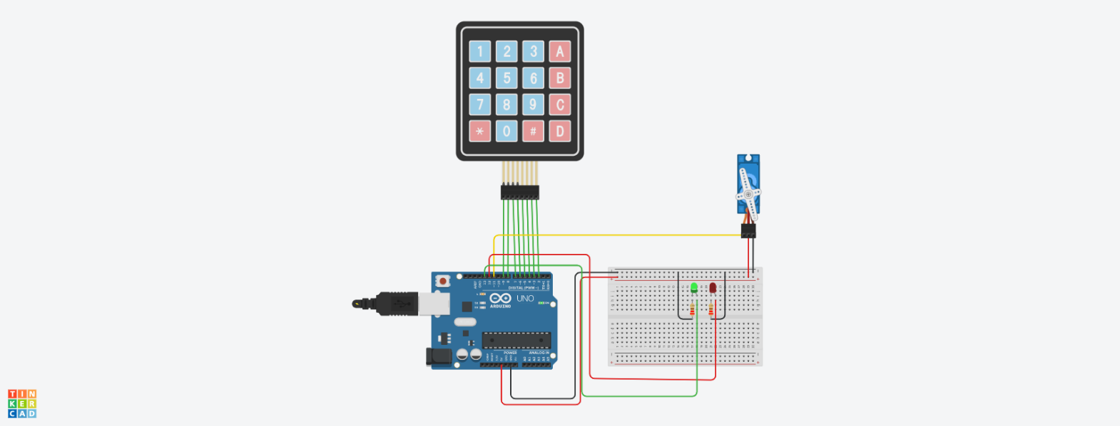

***4X4 KeyPad***

1. **Operating Principle with Diagram**

A matrix keypad is a small compact input device that accepts user inputs and processed by Microcontrollers.  You might have seen this in most commonly used devices like Calculators, Digital locks, Gas pumps and DIY projects. It comes in different types, one of them is membrane keypads, it is thinner in size and you can paste it on top of your creative projects.

If we have to connect 16 buttons to the microcontroller, then each button takes 1 GPIO pin. But if we use the matrix keypad, we just need 8 pins only.

Initially, all rows are set to 0(LOW) and all Columns are set to 1(HIGH). When a key press occurs the **column pin** will get contacted to the **row pin** and makes the entire column state to low. To identify the exact pin at the column, we need to **scan each row by sending 1 (HIGH)** and **read the state at Column pins**. The column which changes the state from 0(LOW) to 1(HIGH) then that is the location of the pressed key (Passes the HIGH signal from Row to Column pin). Let’s see this in detail with an example

In the idle state, the row and column will be like this,

Row                       R1 R2 R3 R4 – 0000

Column                 C1 C2 C3 C4– 1111

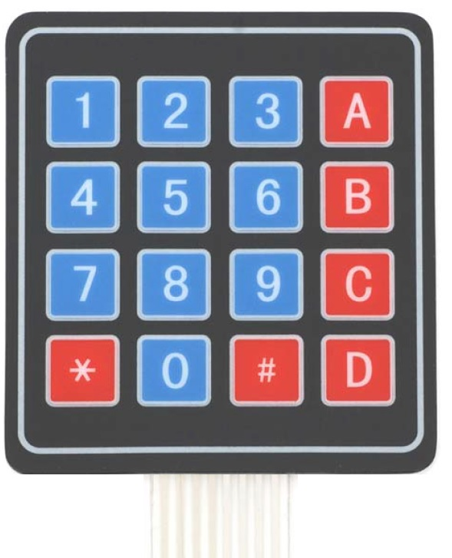

1. **Measurement Range**
2. **Physical Dimension**

Keypad, 2.7 x 3.0 in (6.9 x 7.6 cm)

Cable: 0.78 x 3.5 in (2.0 x 8.8 cm)

1. **Power rating details**

Maximum **Voltage** across EACH SEGMENT or BUTTON: 24V.

Maximum Current through EACH SEGMENT or BUTTON: 30mA.

1. **Pin Diagram**

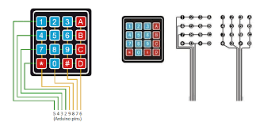

1. **Interfacing with Arduino**

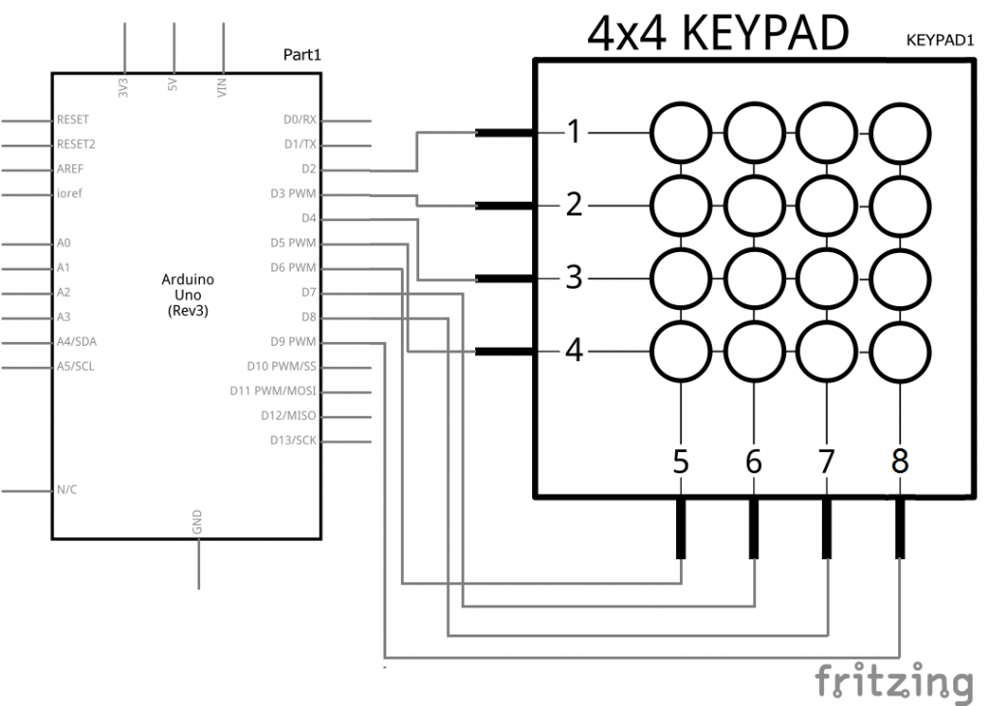

**Simulation Interface of 4X4 KeyPad and Arduino**

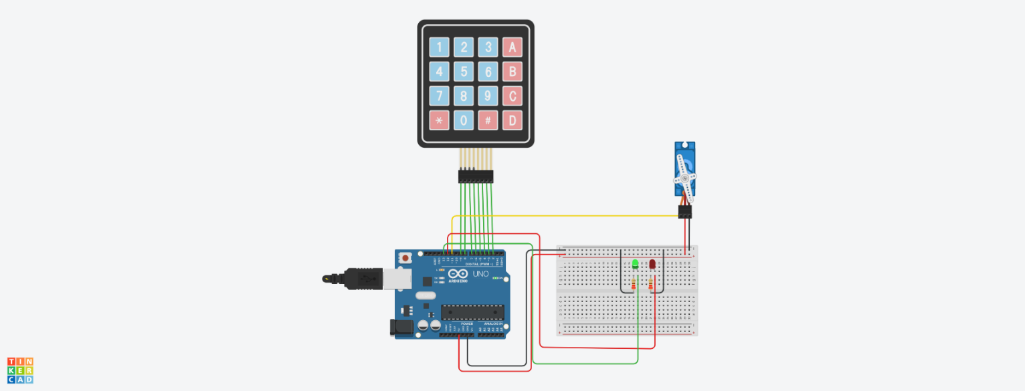

**Appendix A**

1. **IR Sensor**

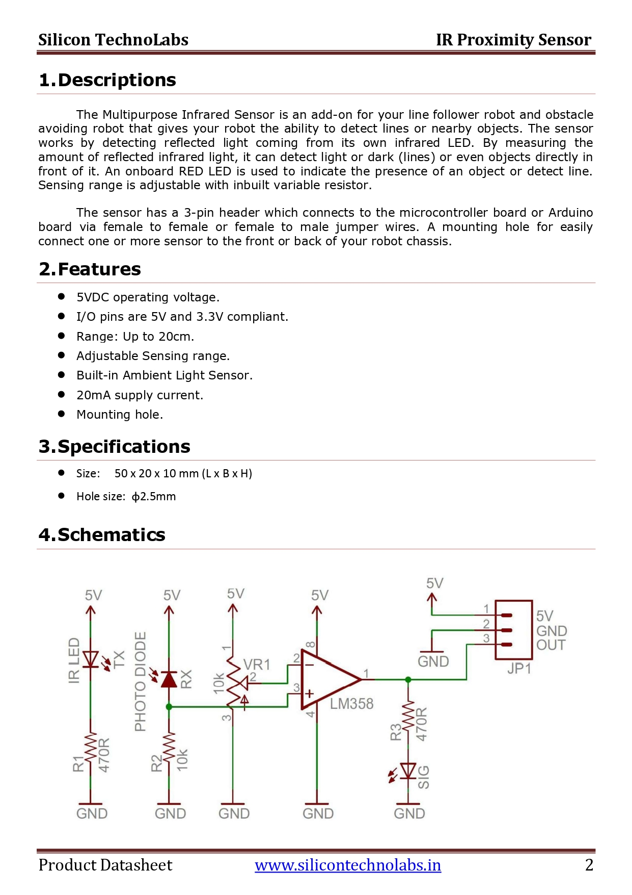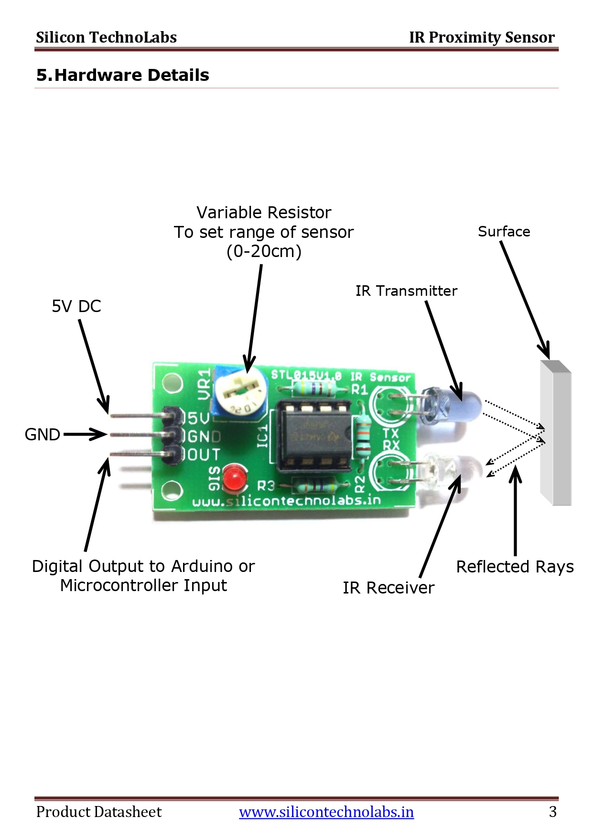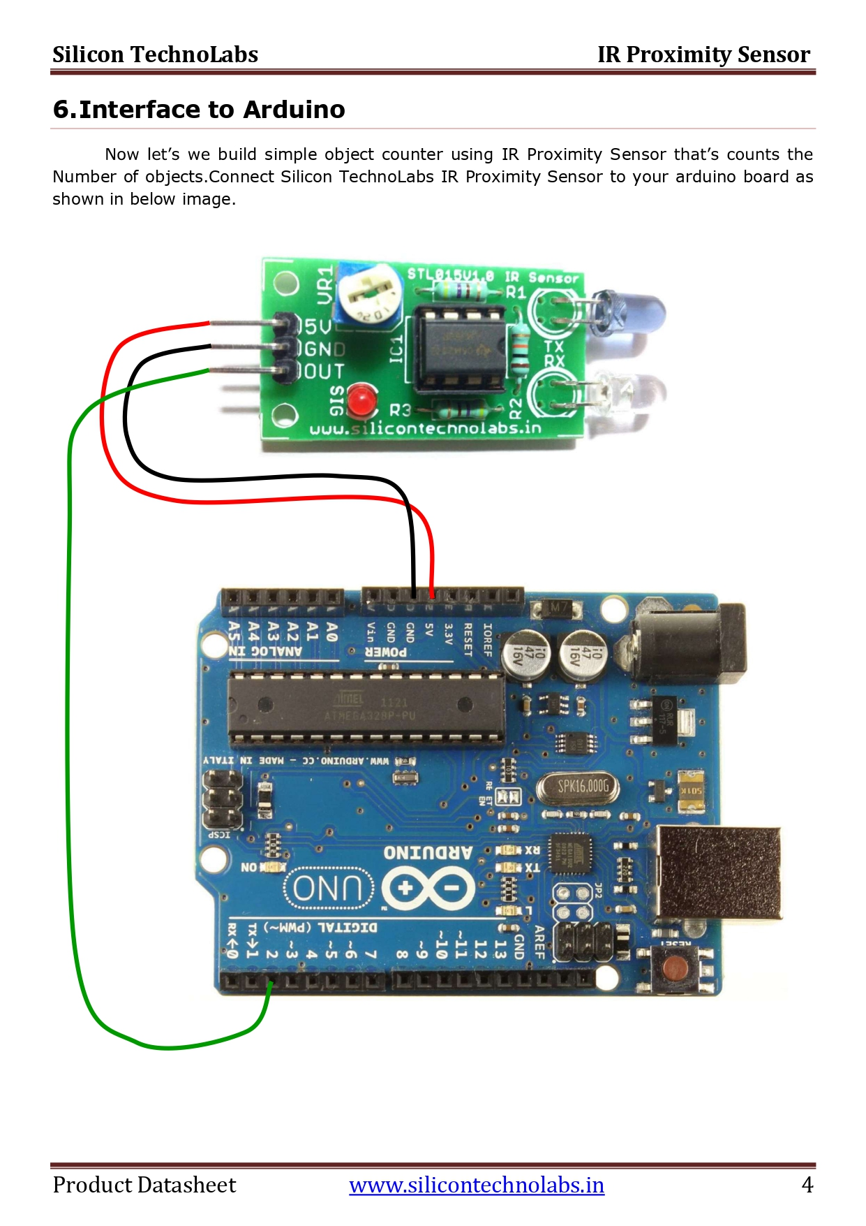

1. **LDR**

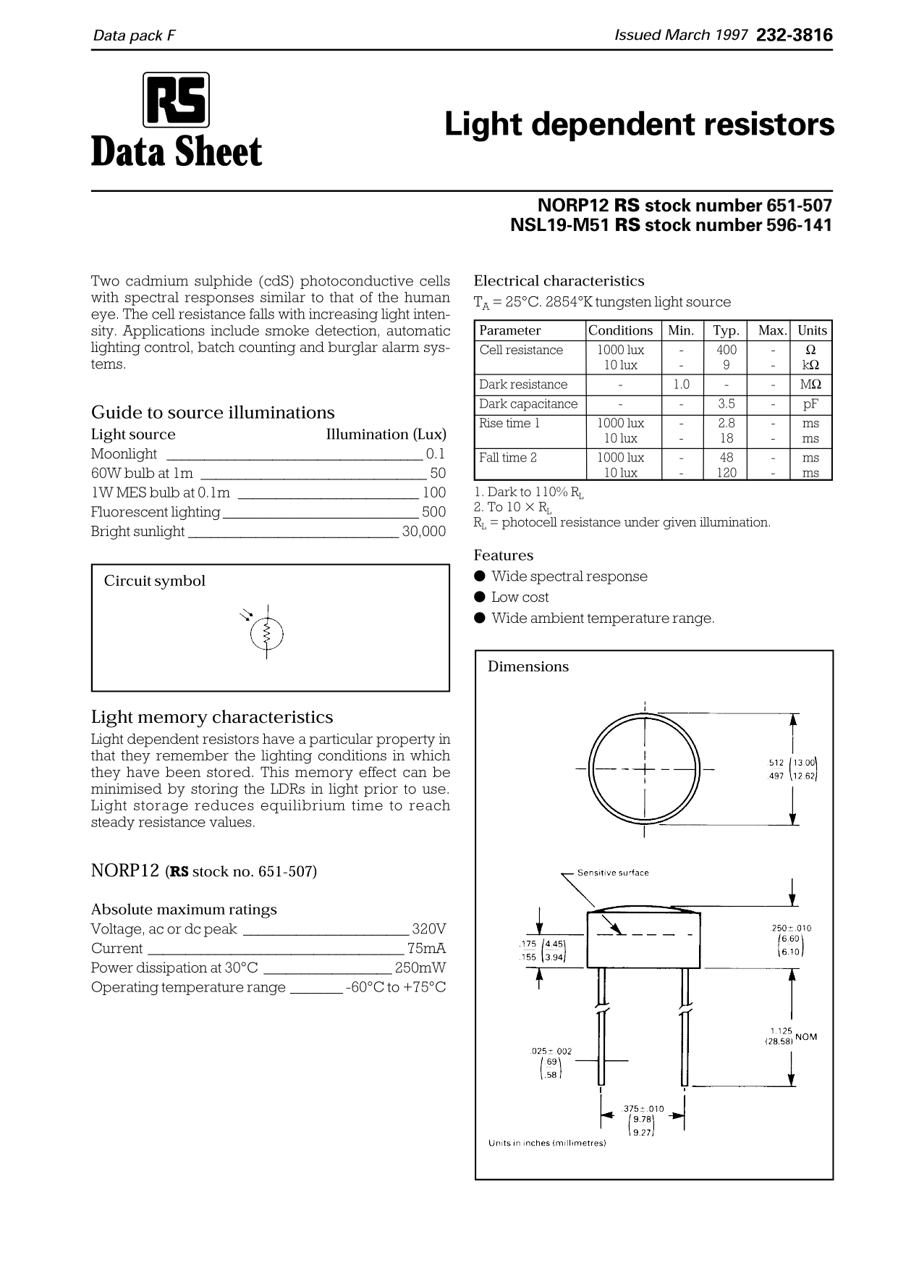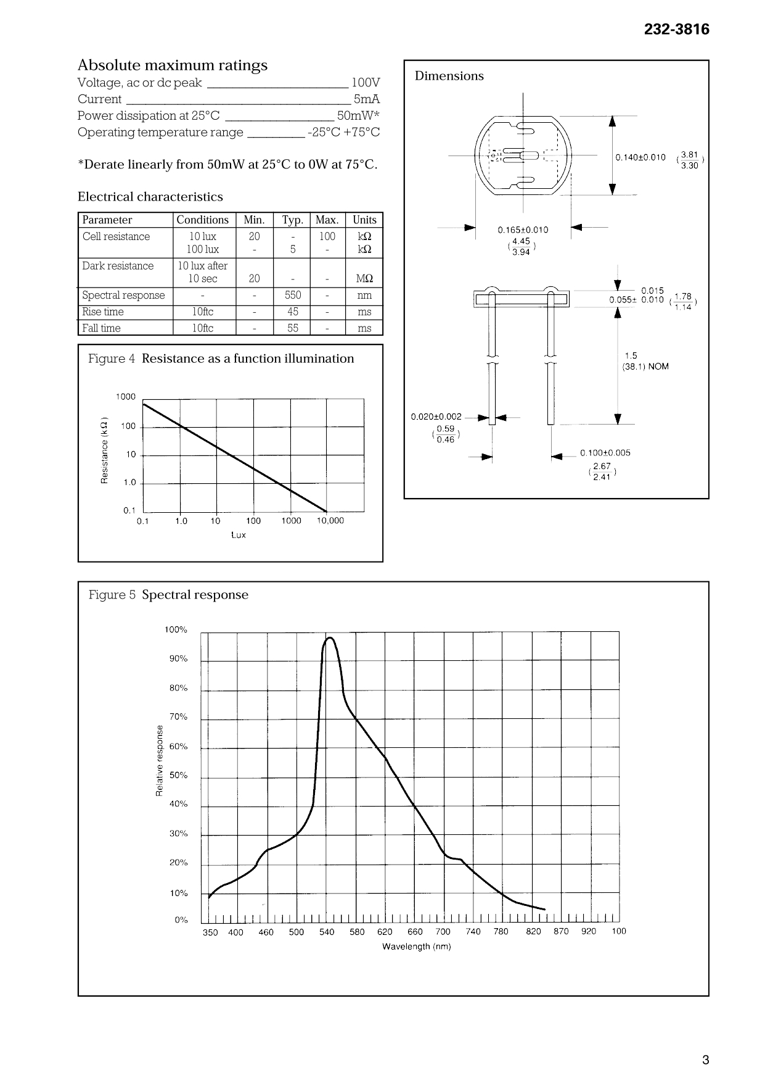

1. **LM35**

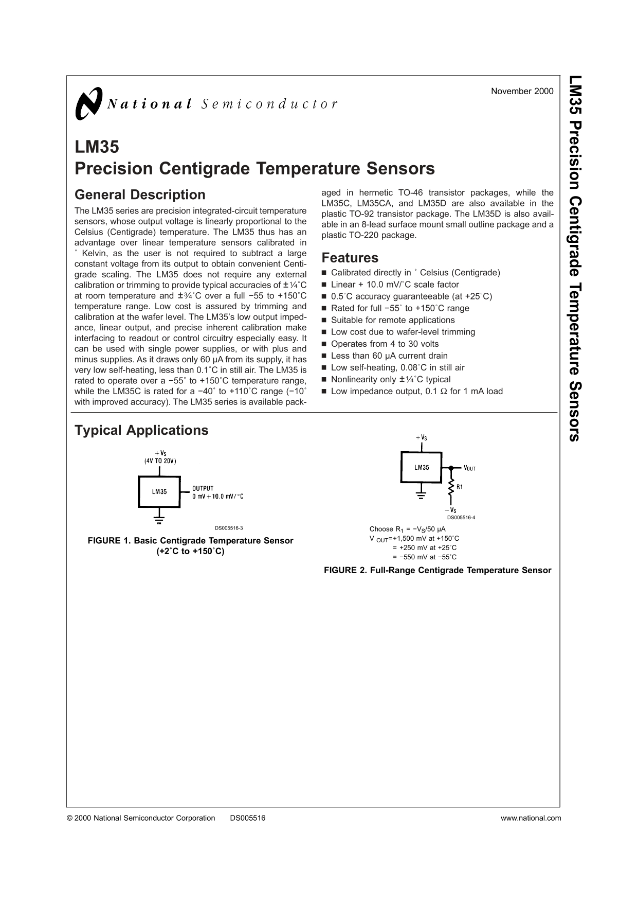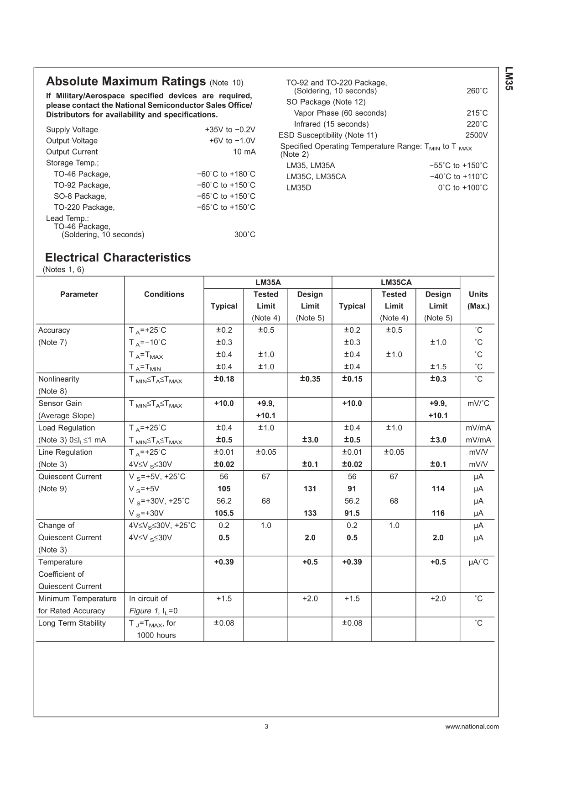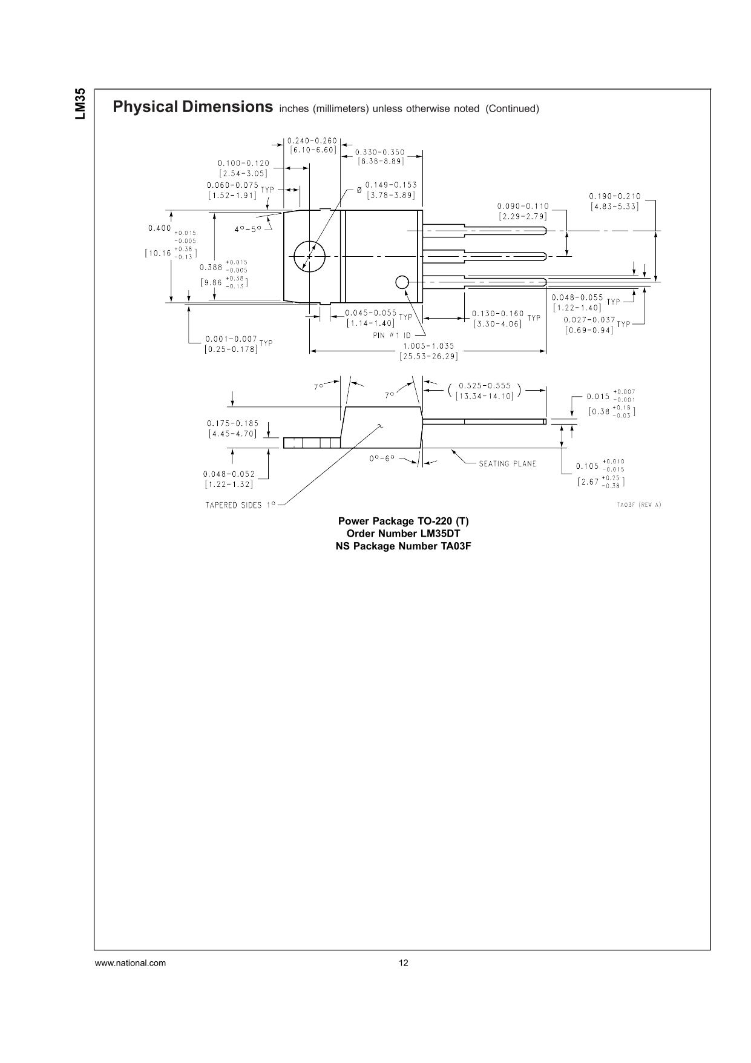

1. **16X2 LCD Display**

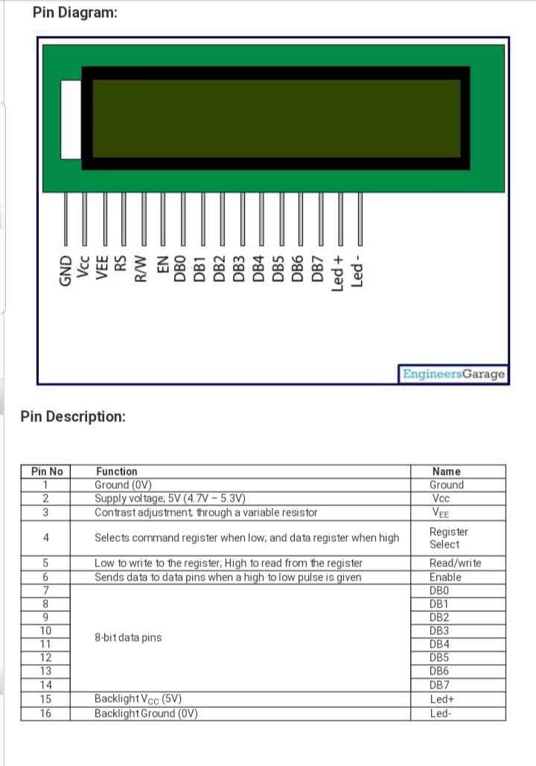

1. **Servo Motor**



1. **4X4 KeyPad**

